F.I.R.E. Carrier Covenant est. 2021

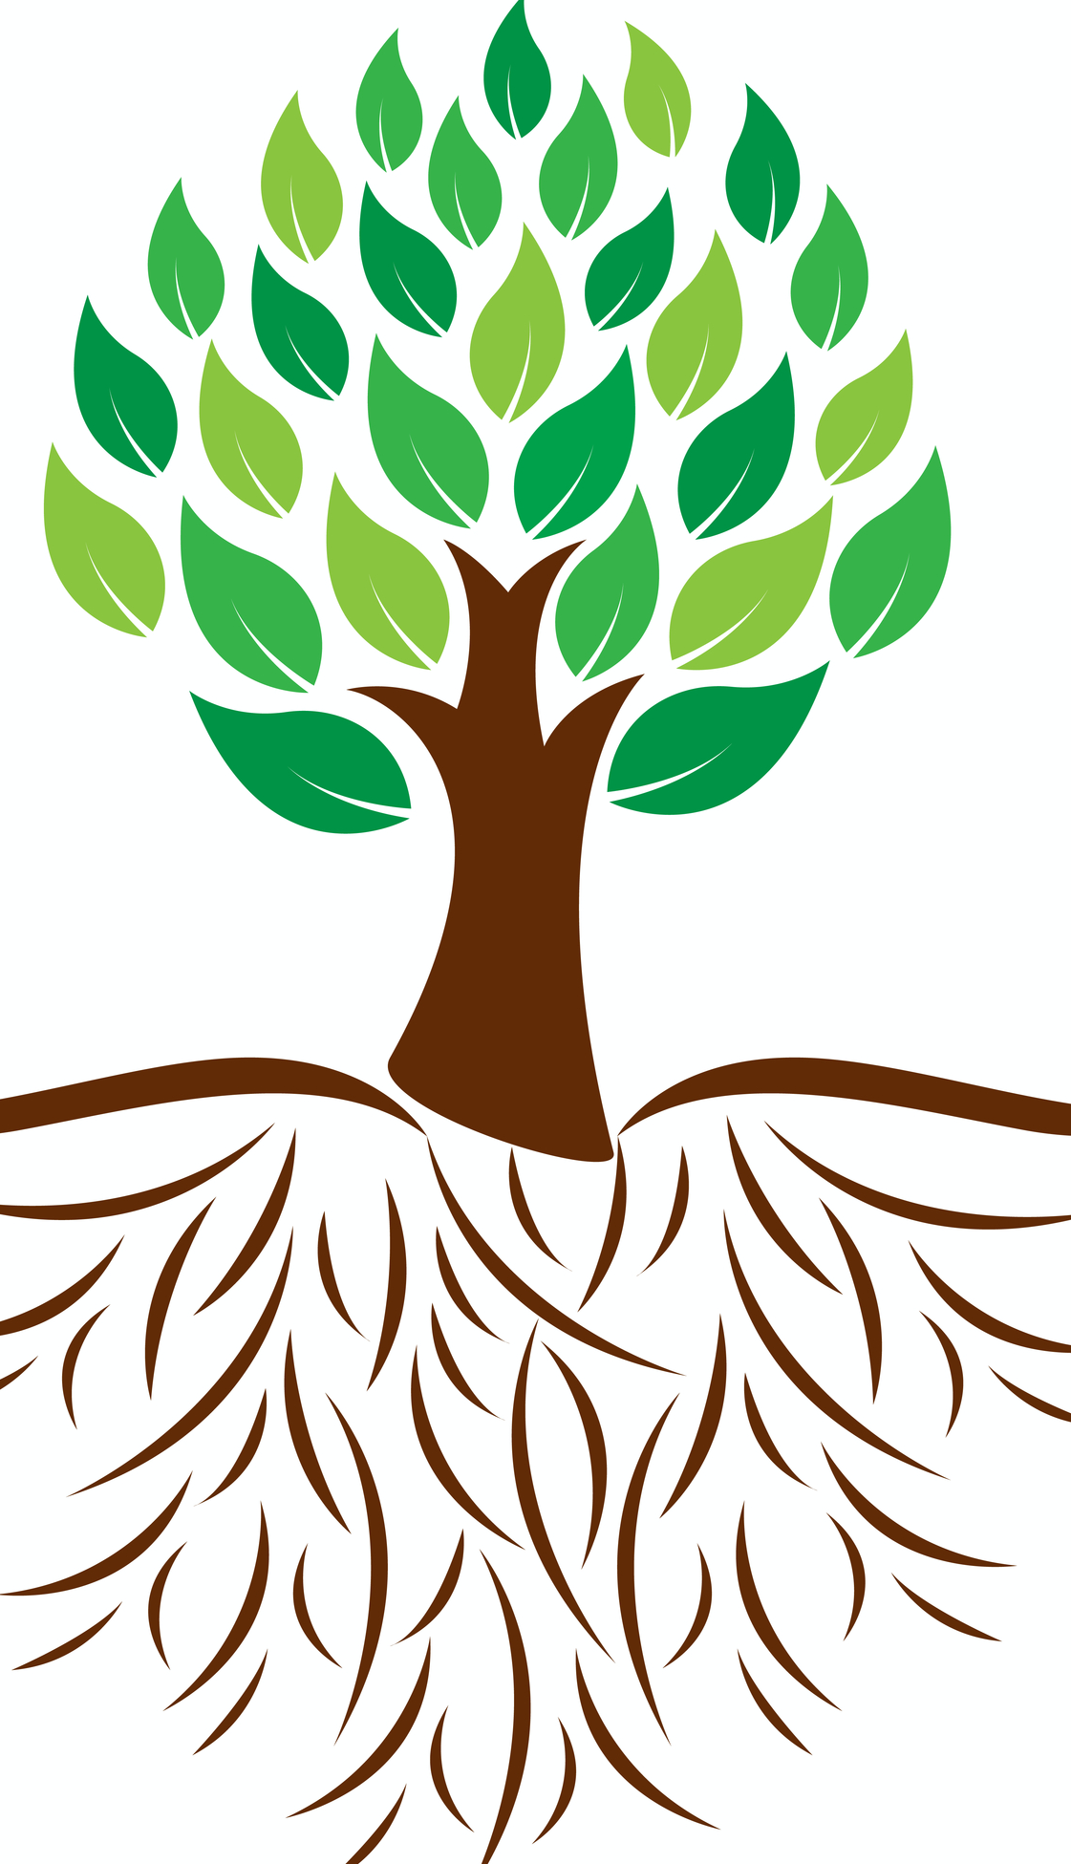

The dream of the FIRE Carrier program is to promote respect, fairness, and inclusion culturally appropriate for Aboriginal / Torres Strait Islander people. The FIRE Carrier promotes, enculturation and reconciliation in our Catholic primary and secondary schools.

To be a FIRE Carrier is to exercise an important leadership role in the school community. FIRE carriers are students and teachers that share a passion for learning about Aboriginal culture and history and are committed to sharing this knowledge and promoting reconciliation within and beyond the school community.

We acknowledge that Aboriginal peoples have been the caretakers of this Land for more than 60,000 years. We respect their spiritual connection to Mother Earth through the Dreaming. We recognise the special place and culture that Aboriginal peoples hold within Yorta Yorta Nation and acknowledge the eight clans and sixteen family groups that make up the nation as the traditional landowners of the country on which our school is situated on.

The purpose of the Covenant is to uphold and recognise catholic justice's response to working with all people within the school community, recognising Aboriginal peoples, their culture and contribution.

Notre Dame College Covenant emphasizes the ethos and faith belief of catholic schools and the social justice response. We are committed to make as part of Christian identity. Notre Dame College expressed commitment is reflected in practical goals and actions which they strive to achieve in the year ahead.
The covenant declares our school and school community’s commitment to stand in solidarity with Aboriginal peoples to achieve true reconciliation and acknowledgement, by all Australians, of their rightful position within Australia.

At Notre Dame College we will:
- Create culturally safe places of learning, growing and belonging for Aboriginal students, families and community members.
- Value the traditional custodianship of the Yorta Yorta Nation and their traditional customs and beliefs.
- Celebrate and value Aboriginal history and culture and their significant dates.
- Seek the assistance and expertise of, and work in authentic partnership with, Aboriginal Education Workers, local Aboriginal communities, and the Sandhurst Aboriginal Education Team

All Notre Dame staff will:
- Be formed and informed so as to incorporate the Aboriginal perspective respectfully and accurately across the curriculum as outlined in the Victorian Curriculum and where advised from local elders.
- Ensure all staff have regular access to, and engage in, Aboriginal education professional learning.
- Create school cultures where Aboriginal students are proud of their identity and grow to their fullest potential.

Our School
Our vision for reconciliation is to be a place of learning and sharing, showing respect and including Aboriginal people. We will continue to build strong and trusting relationships with Aboriginal communities. These relationships will provide sharing of knowledge providing our school community the opportunity to listen and learn from our local Aboriginal peoples, about the past, the present, and their vision for the future. We will be a place where Aboriginal culture is respected and celebrated.



Spirituality - This symbol Aboriginal painting means campfire. The campfire represents the spiritual connection between individuals to Mother Earth. It is where families meet, stories are told, traditions are shared and lores are taught.


Cultural Recognition and Awareness - This symbol represents the Message Stick. The Message Stick is a wooden stick that is passed between clans and language groups to transmit messages, invitations, and information. In the FIRE Carrier program, we use the Message Stick to signify Cultural Recognition and Awareness. We Invite you as a part of the FIRE carrier program to join us in promoting the message of Eco Stewardship/stewards of the earth.


Practical Reconciliation and Justice - This symbol represents journey in Aboriginal painting. It has been chosen to represent the journey towards Reconciliation for Aboriginal peoples. We invite you as part of the FIRE Carrier program to join us on this journey in honouring the earth as Eco Stewards.

Ecological and Custodian Stewardship - The Spirituality of Aboriginal peoples connection with Country and nature are still deeply rooted in their DNA today. Ecological renewal and sustainability depend upon spiritual awareness and an attitude of responsibility and gratitude, the recognition of creation as sacred and behaviours that honour that sacredness. The message of Eco Stewardship aligns with the Aboriginal ‘way of knowing’ The earth is the central spiritual context, an attitude and ‘way of being’ in the world, rooted in land and embedded in place. Recognizing cultural perspectives and demonstrating awareness through looking after and caring for the country sends a strong message. Throughout Australia Aboriginal people have an intimate knowledge of local terrains. For Aboriginal people land is a story place. It holds the stories of human survival across the generations. Land shapes people, just as people shape their countries. Australia is interwoven with the tracks of the dreaming/song lines. We invite you to join with the story of this land and honour creation as sacred while displaying an attitude of responsibility for the Earth as ecological stewards and custodians.

CHILD SAFE STANDARDS -

- Organisations establish a culturally safe environment in which the diverse and unique identities and experiences of Aboriginal children and young people are respected and valued.

1.1 A child’s ability to express their culture and enjoy their cultural rights is encouraged and actively supported.

1.2 Strategies are embedded within the organisation which equip all members to acknowledge and appreciate the strengths of Aboriginal culture and understand its importance to the wellbeing and safety of Aboriginal children and young people.
1.3 Measures are adopted by the organisation to ensure racism within the organisation is identified, confronted and not tolerated. Any instances of racism are addressed with appropriate consequences.
1.4 The organisation actively supports and facilitates participation and inclusion within it by Aboriginal children, young people and their families.
1.5 All of the organisation’s policies, procedures, systems and processes together create a culturally safe and inclusive environment and meet the needs of Aboriginal children, young people and their families.

Spirituality
Focus Area: Learn, Teach, Share, Grow towards understanding Aboriginal Spirituality (holistic)
Action |  | Responsibility |  | Timeline |  | Suggested Activities/Resources
Through Prayer and knowledge gain/engage a deeper awareness of justice issues.  Use Aboriginal songs and meditations for morning prayer.  Acknowledgement at Pastoral Group.  Explore the significance of spirituality in Aboriginal art,  Create an Australian identity during time of Advent.  Develop an understanding of Aboriginal Spiritual connection to country. The Dreaming. |  | Religious Education Leader  Pastoral Group Leader.  Religious Education Leader, Aboriginal Education Worker  Art department  Religious Education Teachers  Students  Religious Education Leader  Learning Mentors with support from Aboriginal Education Worker |  | Ongoing  On going  Ongoing  Beginning Advent annually  Ongoing  Ongoing |  | - Welcome to Country / Acknowledgement to Country by Aboriginal Elder or Student  - Continue to incorporate Aboriginal prayers and symbols in liturgy by using the message stick during reading of the Word and at school masses.  - Learn and use the Aboriginal Prayers for the opening of the school year mass, so that it may be incorporated into Pastoral Groups and used by the community at other year level liturgies.  - Introduce Richard Campbell’s Stations of the Cross to the college community  - Perform ‘Turning of the Coolamon Ceremony’ using the Coolamon Liturgy in a staff liturgy for Advent  - Investigate possible resources to purchase for use in the school’s Religious Education Program, to break open the Indigenous perspectives  - Investigate significant local Indigenous sites as possible excursion locations for all students.  - Listen to Dreamtime and Dreaming creation stories/ philosophies.  - Smoking Ceremony- Reconciliation Assembly, Harmony Day and at special staff and student gatherings

Practical Reconciliation & Justice
Focus Area: Walk the Journey together, Put Learnings into Practice

Action | Responsibility |  | Timeline |  | Suggested Measurable Target
Take Practical Measures toward Reconciliation and Justice  Acknowledge and teach the ‘true’ history of Australia  Empower the FIRE Carrier leaders to share the learning and message within the school  Fly the flags and have Aboriginal artefacts present around the school.  Display Acknowledgement to country plaque at entrance of school on all campuses and buildings.  Aboriginal Student Committee. | Principal, Whole school Community  Learning Mentors  Principal, Religious Educator, Aboriginal Education Worker  Principal, Fire Carriers, Koori Education Worker  Principal,  Aboriginal Education Worker |  | Ongoing  Ongoing  Ongoing  Daily |  | - Display the Aboriginal and Torres Strait Islander flags  - Teach and learn the truths of history  - Display Acknowledgment of Country in entrance to office, buildings, and classrooms.  - Display and maintain Aboriginal artefacts in the front office. Add to this display over time. Place artefacts in class areas so children can engage, and teachers can incorporate into their daily learnings.  - Have elders come in and share their personal journeys and life experiences  - Attend significant gatherings such as Reconciliation Masses  - Make links to Victorian curriculum. Australians together.  - Provide learning opportunity for FIRE Carrier teachers & students to grow their knowledge and understanding  - Provide opportunities for FIRE Carrier leaders to pass on their knowledge and learning  - Display Fire carrier elements
Ecological and Custodian Stewardship
Focus Area: Ecological renewal and sustainability depends upon spiritual awareness and an attitude of responsibility – Caring for country

Action | Responsibility |  | Timeline |  | Suggested Measurable Target
Take Practical Measures toward teaching and learning of how Indigenous people cared for and lived off the land  Develop knowledge and skills of our Sustainability leaders and FIRE Carriers  Engage in Sandhurst switches off  Celebrate Earth Hour.  Empower the FIRE Carrier leaders to share the learning and message within the school  Share the story of Totems how they are attached to the environment and what that means for us today regarding Ecological Stewardship. | Learning Mentors  Sustainability Coordinator and Religious Education Leader  Sustainability Coordinator  Religious Education Leader  Sustainability Coordinator and Religious Education Leader |  | At appropriate times within curriculum plans  Ongoing during FIRE carrier and Sustainability meetings  March annually  Ongoing  Ongoing |  | - Teach and learn the Indigenous way of living  - Design a native plant garden with Aboriginal community  - How did Aboriginal peoples live off the land and keep it sustainable? (invite elders to share)  - Diet  - Medicines  - Backburn  - Sign up to Earth Care.  - Sustainability leaders share learning and provide opportunities for the whole school to be engaged and immersed in particular ways to help the land and country  - Excursions on country  - Provide opportunities for FIRE Carrier leaders to pass on their knowledge and learning.  - Students will be able to recall and retell the story.  - Create an Indigenous space as a learning space to tell this story

Cultural Recognition and Awareness
Focus Area:
Action | Responsibility |  | Timeline |  | Suggested Measurable Target
Cultural Awareness professional development for Staff  Cultural experiences for student  Curriculum development | Aboriginal Education Worker  Aboriginal Education Worker  Learning Area Convenors/  Aboriginal Education Worker |  |  |  | - Excursions to Country with Yorta Yorta Nation Aboriginal Corporation  - Immersions on The Flats, Winton Wetlands and Barmah  - Make links to Victorian curriculum, Australians Together  - Visitng Elders at Rumbalara Aboriginal Co-operative  - Students and staff collaborating with Australians Together research project

The FIRE Carrier Project is an initiative of the Aboriginal Catholic Ministry, the Opening the Doors Foundation and the Sandhurst Catholic Education Office, to promote and assist Reconciliation through Education in our Schools.

Our School commits to completing or putting steps in place to complete all Actions through Measurable Targets outlined above by the dates set out in the timeline above. A review at the end of the school year will be conducted and the plan will be updated and passed to the following year's FIRE Carrier.

